1. **User Manual**
   1. **Admin Side:**

##### Login:

* + - * Admin needs to login in order to operate the website.
      * He/she can login by enter his/her credentials in the form.
      * After entering credentials click login.

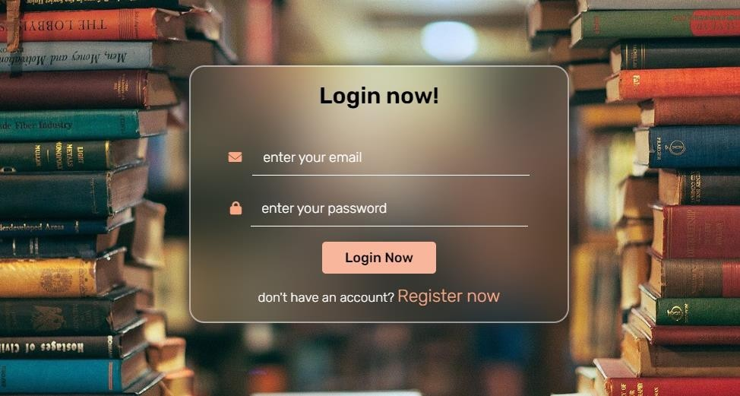

##### Dashboard/Home:

* + - * The homepage or the dashboard is too monitor the entities of the website.
      * The admin can detail such as Payments due, Payments completed, Order Places, Number of Products, Number of Users, No of Admins, and Numbers of messages received.
      * The admin cannot change anything on the dashboard and will have to go to other pages.

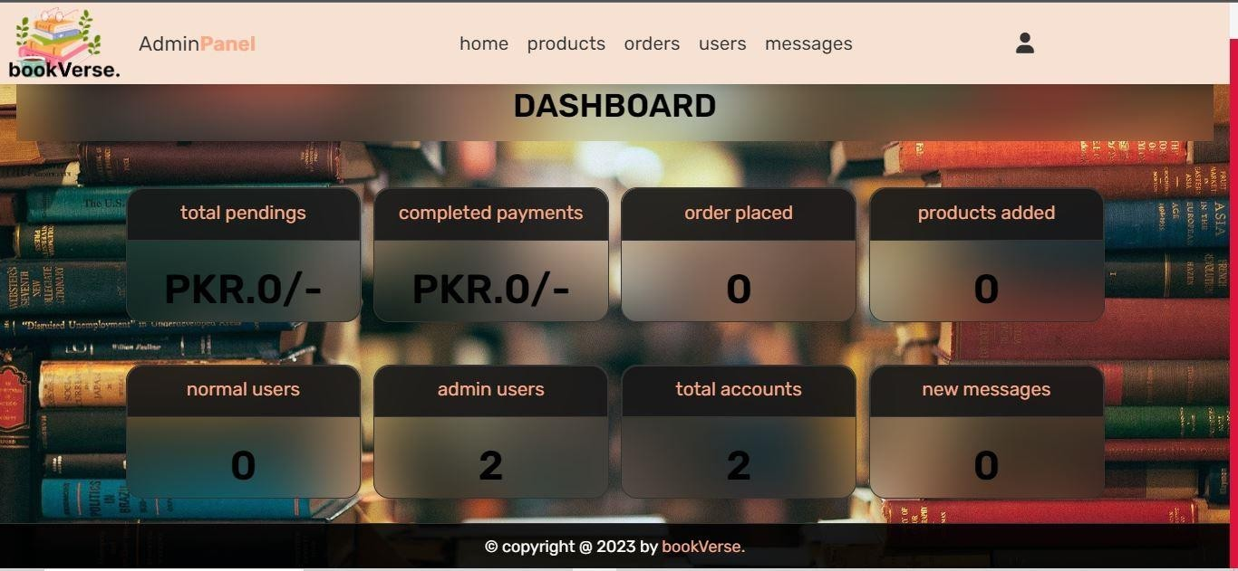

##### 1.1.3 Add a Product:

* + - * In order for admin to add a product he/she has to fill the form.
      * The add form consists of Name of Book, Name of Author, Price of Book, Number of Copies available, Genre, Description and a Photo of its cover.
      * The cover photo can be selected from the photos save in the system.



* + - * Once the Book is added its detail will appear below.
      * The details of the book can be update by clicking update button.
      * A form box will appear, where admin can what he/she wants to change.
      * All the changes can be implemented by clicking the delete button.
      * The delete button is remove the book from products.

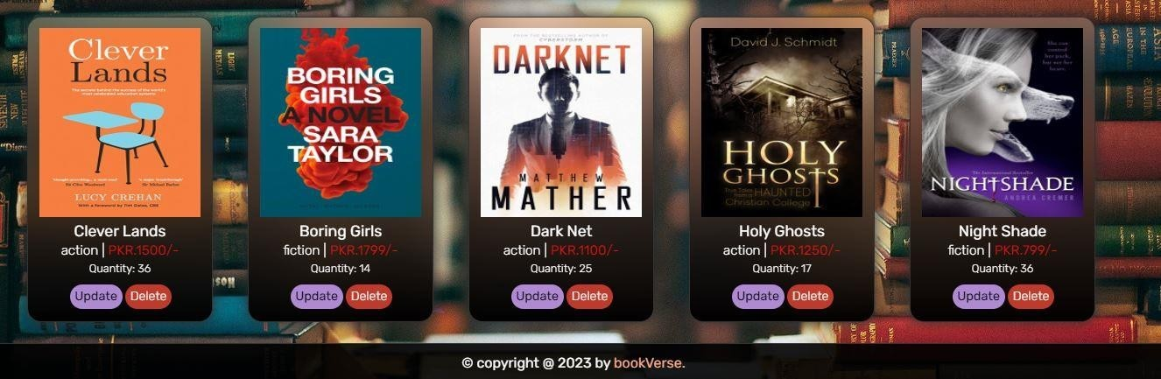

##### 1.1.4 Orders:

* + - * Orders page is to view all the orders.
      * Admin can update the payment status to complete or pending by changing it from top down menu.
      * After selecting status click Update Button
      * The details such as user name, address and total price appears in one order box.
      * Admin can also delete an order completely by clicking on the delete button.

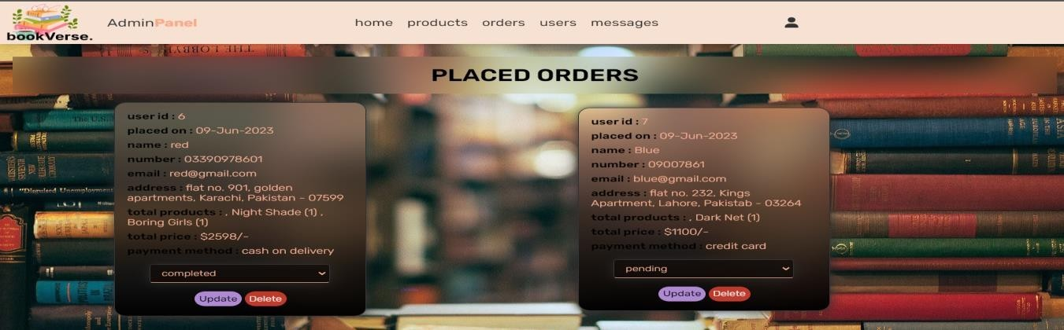

##### Users:

* + - * Users page display’s all the registered users and admin.
      * Admin can delete a user by clicking on the delete button.

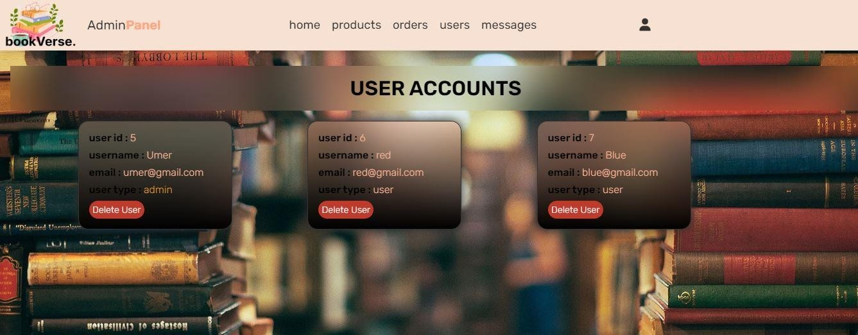

##### 1.1.6 Messages:

* + - * The Messages page is to see all the questions and comments by the users.
      * Admin can delete message by clicking delete button.

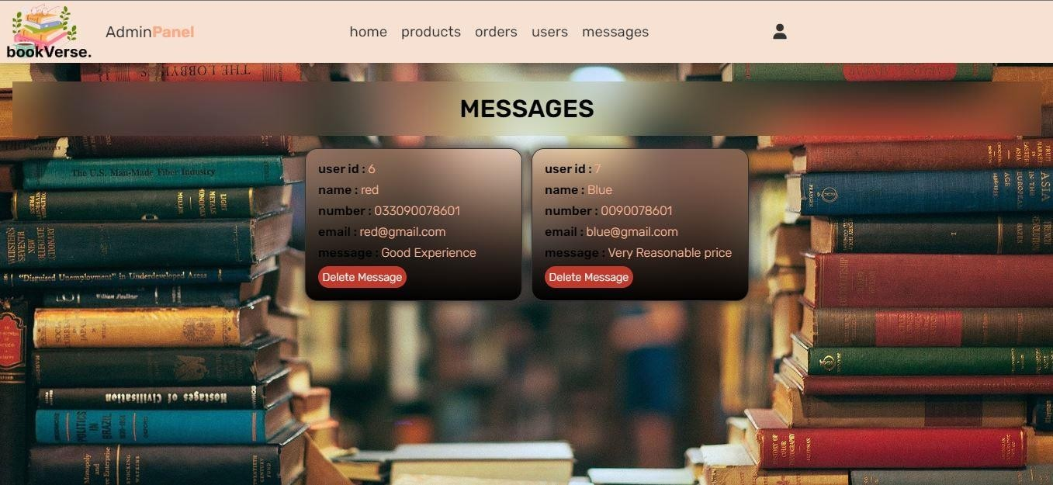

# User Side:

##### 1.2.1 Home:

* + - * Home is just used to display some featured products.
      * Through home page user can go to shop page, contact us, and about us.

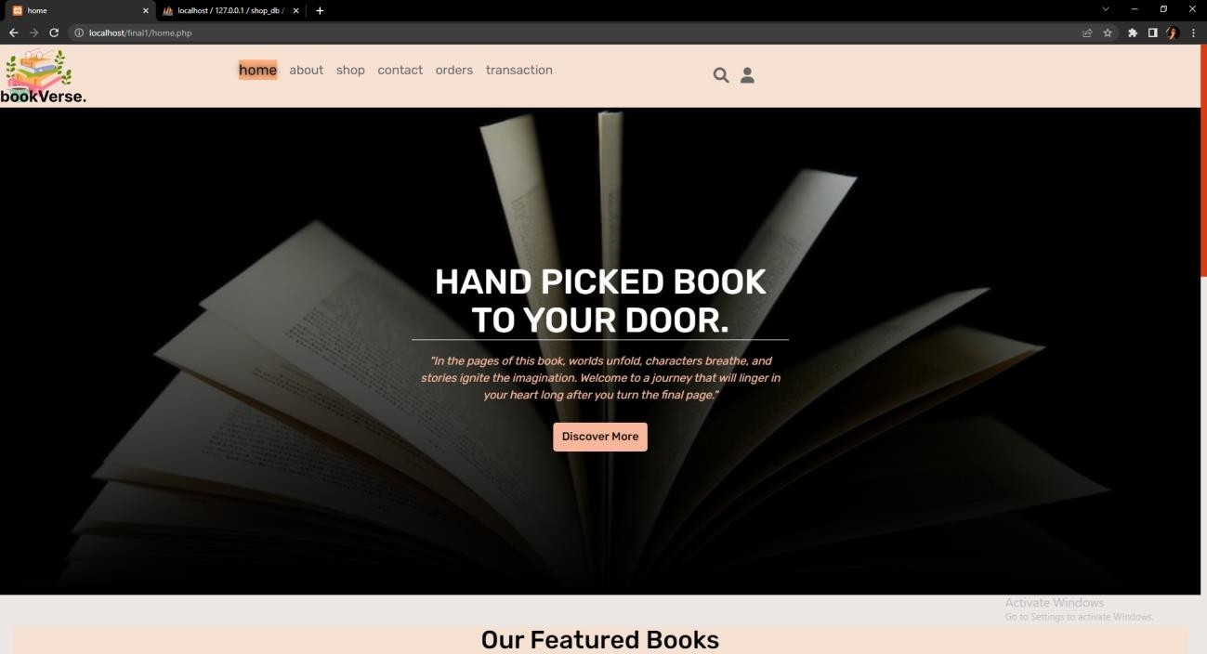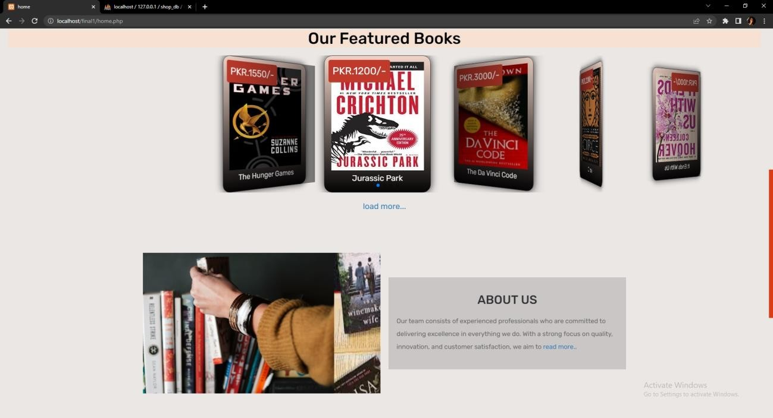

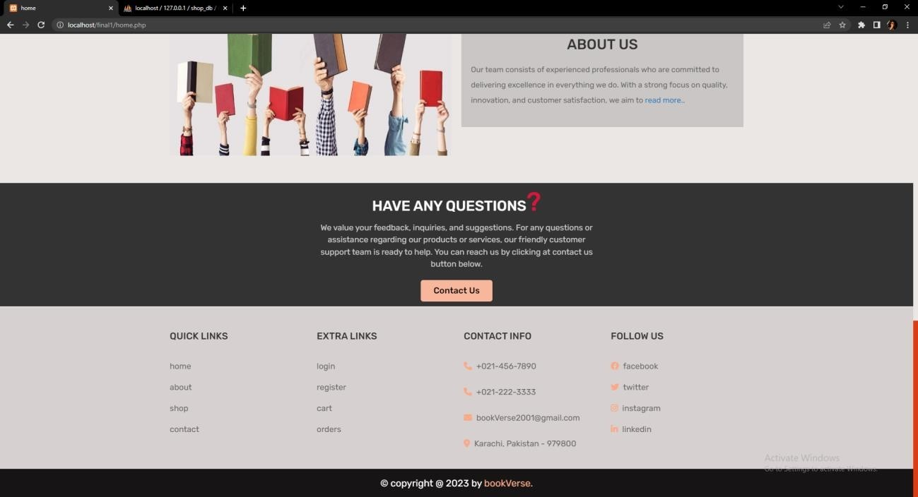

##### 1.2.2 Shop:

* + - * Shop page is to display all the books available.
      * The page is categorized according to genres.
      * It also displays the featured books.

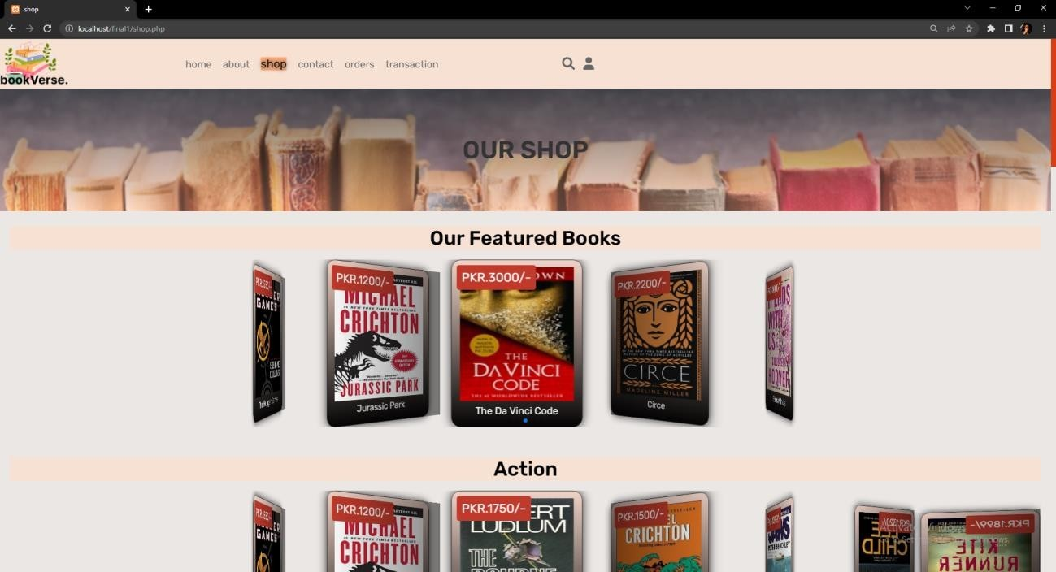

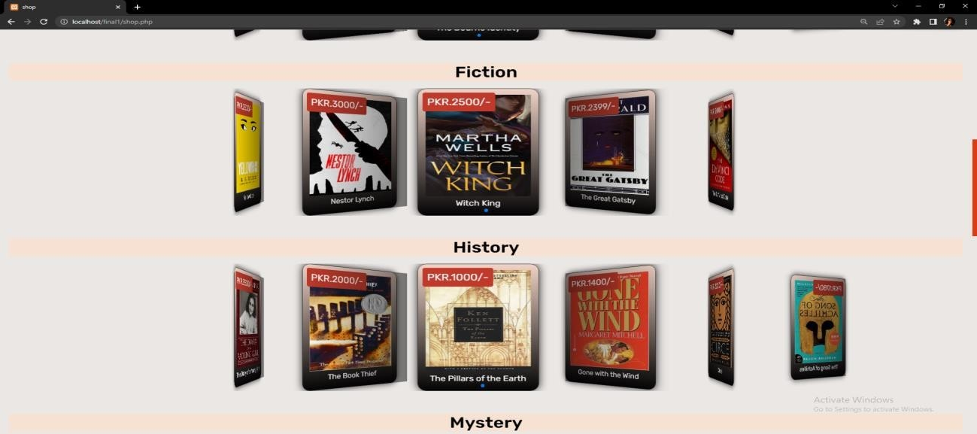

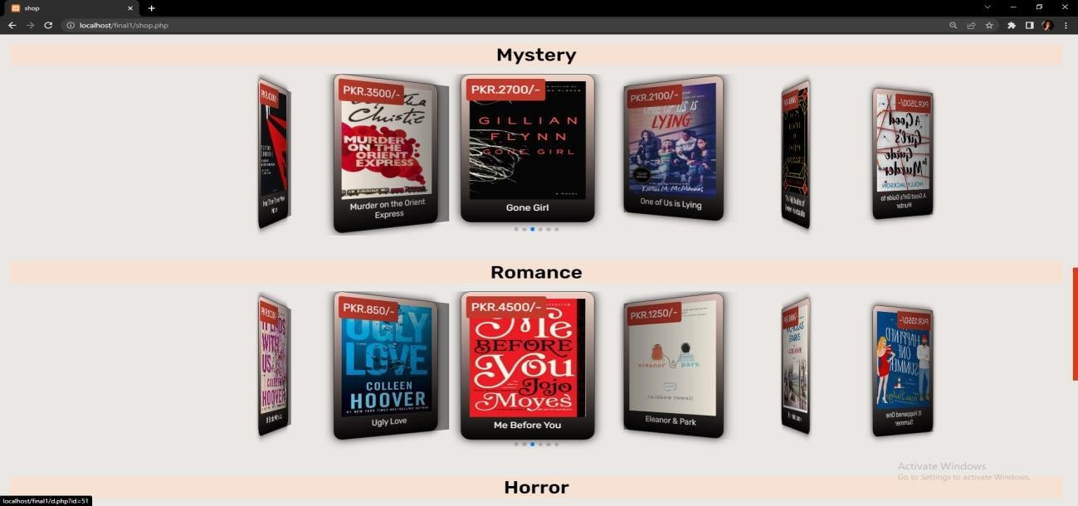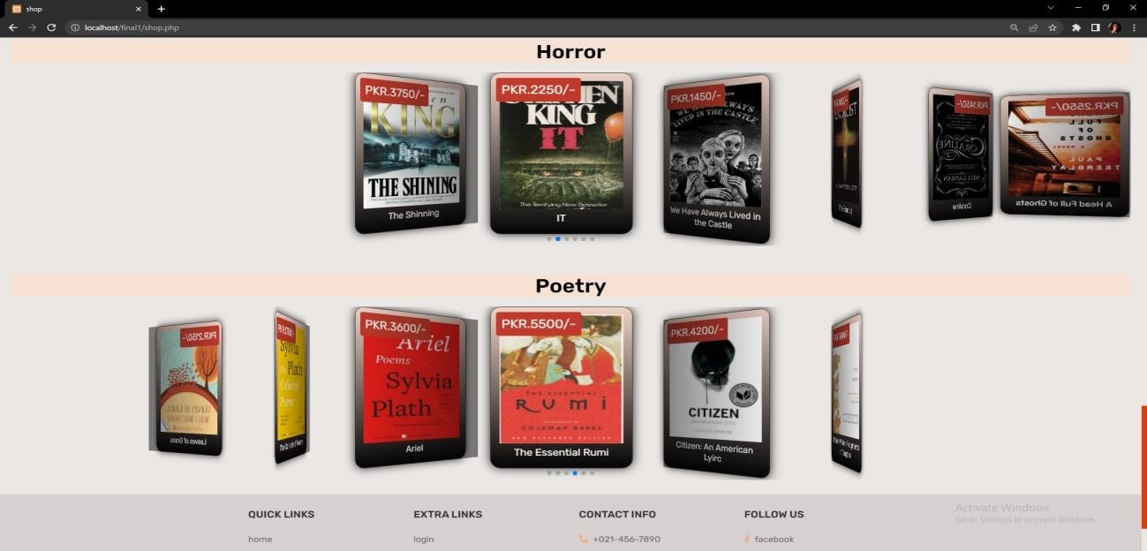

##### 1.2.3 About us

* + - * About us page is to display what is website for.
      * It also displays testimonials of users.

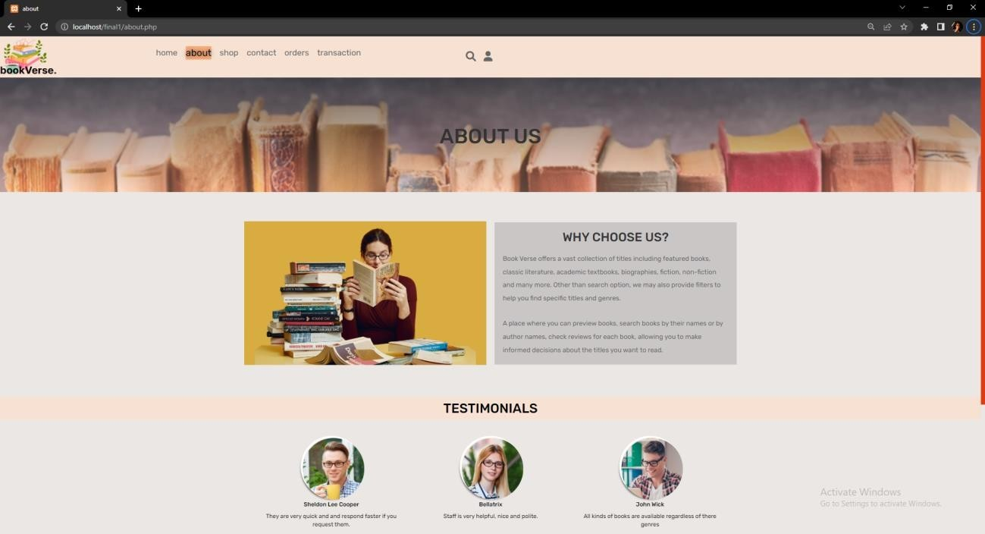

# 1.3 How user can Interact with the website:

#### 1.3.1 Register

* + - * + In order to interact with the website user has to register himself.
        + For user to register, he has to provide name, email, and password.
        + The format of email should be in a correct format i.e. [example@gmail.com](mailto:example@gmail.com).

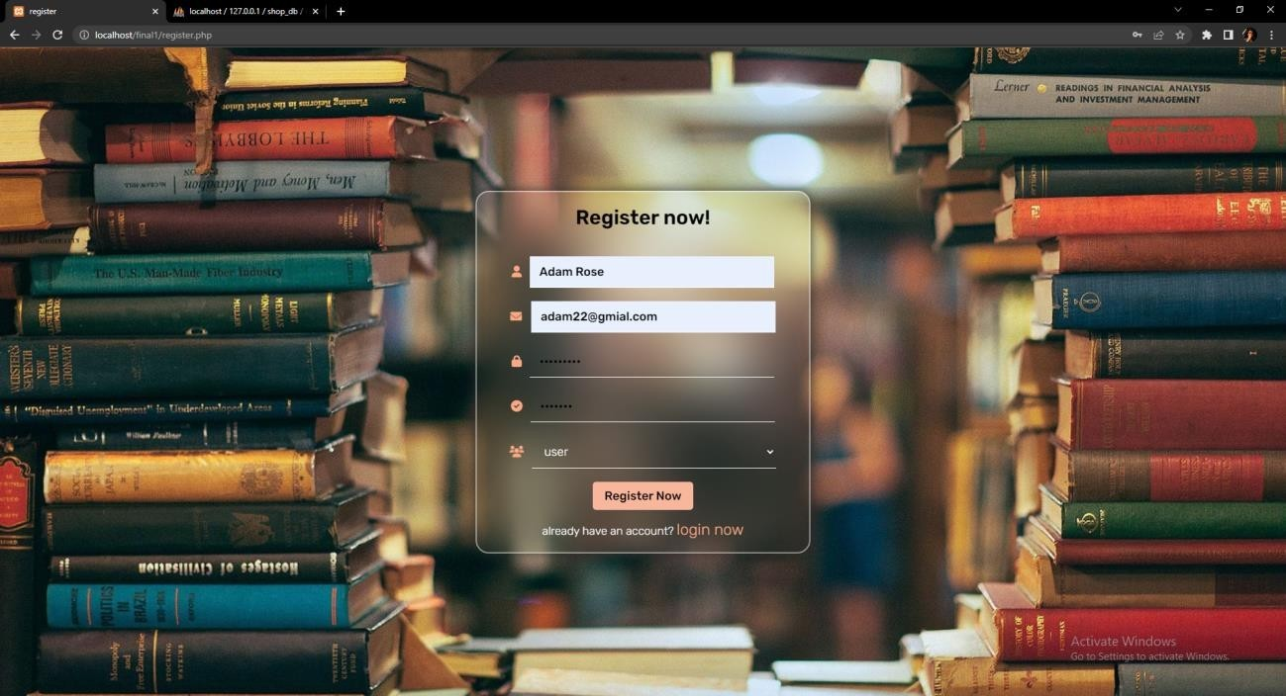

#### 1.3.2 Login

* + - * + Once the user has registered himself, he will be redirected to login page.
        + He can log in by simply writing the registered email and its password.

#### 1.3.3 Buying a Book

* + - * + User can buy a product from shop page.
        + The user has to select a book and its quantity.
        + After selecting the quantity, he can add it to cart.
        + And if he wants to continue, he can add other products.
        + And if he wants to checkout he can click on the cart logo on the top right corner it will redirect him to the cart.

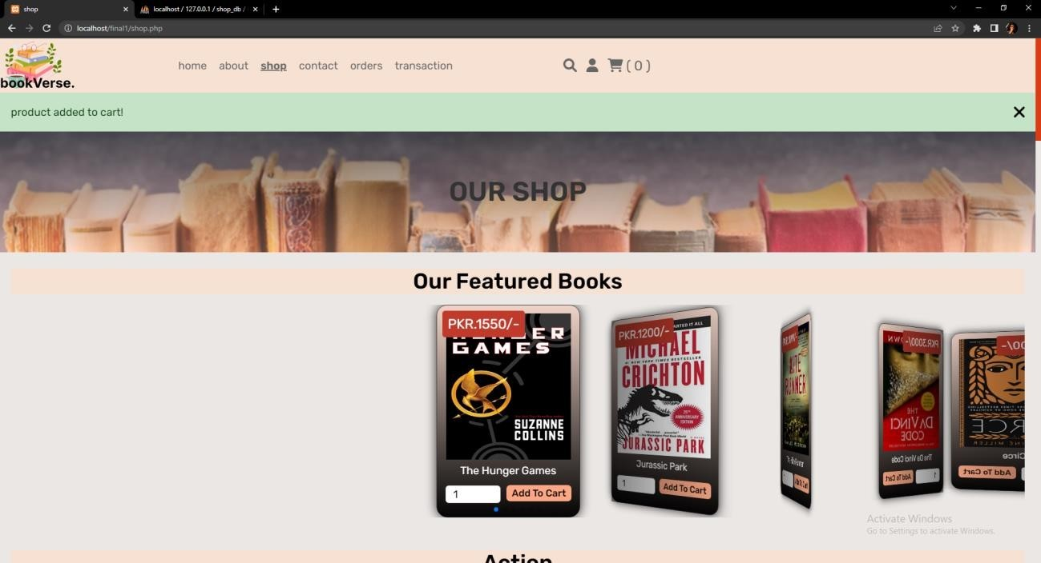

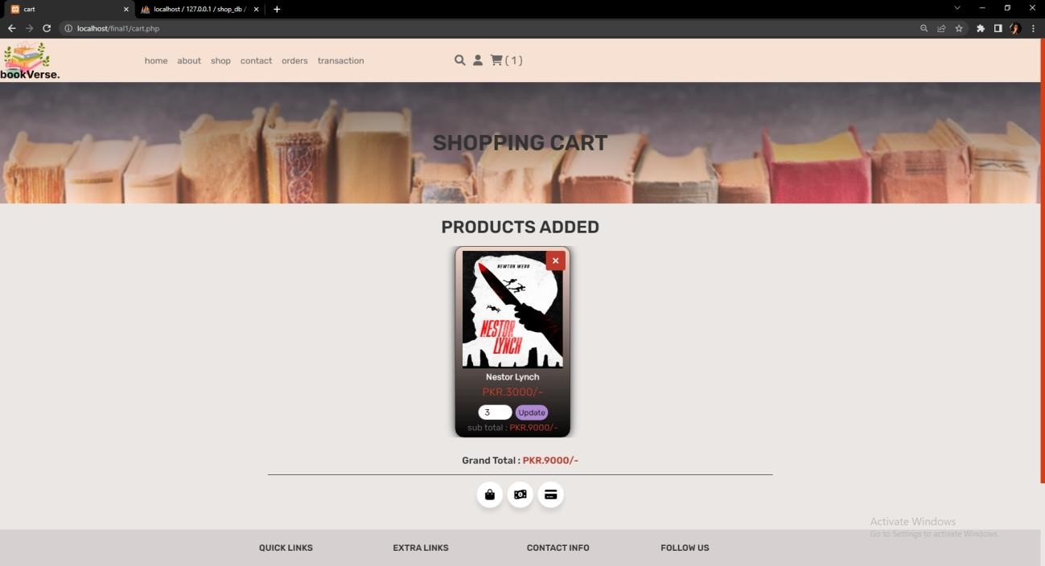

#### 1.3.4 Checking Out:

* + - * + In order to check out user has to first, select the payment method.
        + After selecting the payment method, he will be redirected to checkout form.
        + The form consists of name, email, phone number, address, city, country and postal code.
        + After entering the details, a form opens for user to enter his credit/debit card information if the user has selected online payment method.
        + And if user has selected Cash On Delivery, his order will be confirmed.

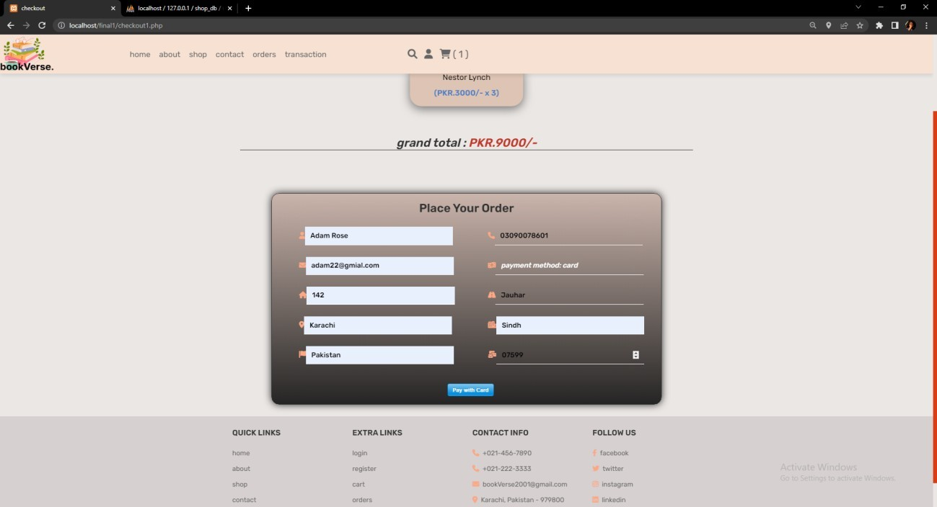

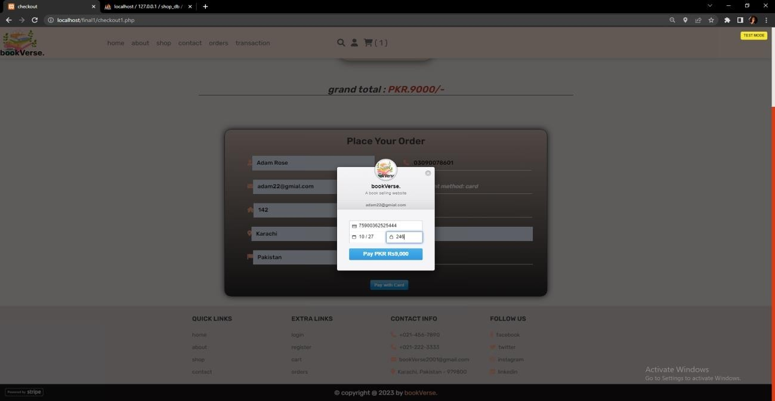

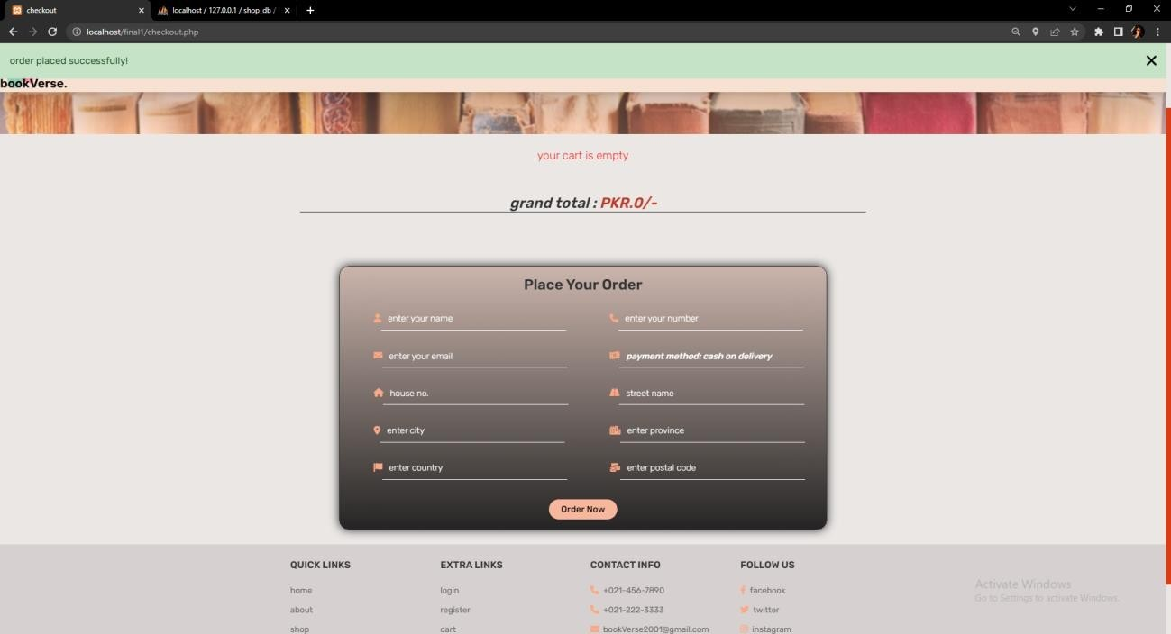

#### 1.3.5 Orders

* + - * + Once the user, has confirmed a purchase, his order will appear on the orders page.
        + This page displays information such as name, order, address and payment status etc.

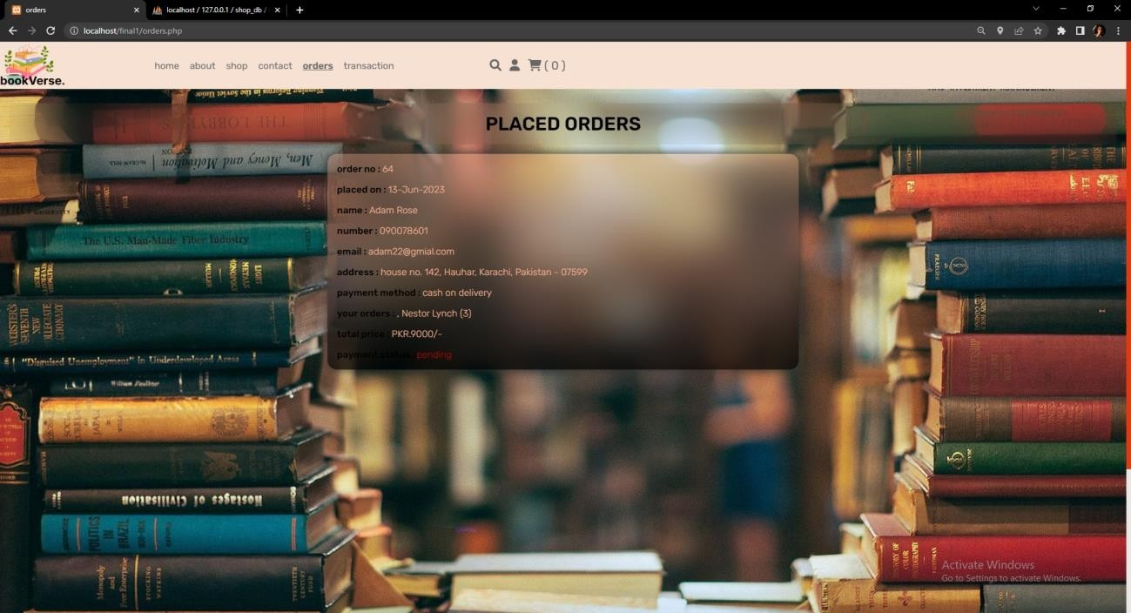

#### 1.3.6 Transaction

* + - * + The transaction page is used to display all online payment done by the user.
        + This does not display order of cash on delivery.

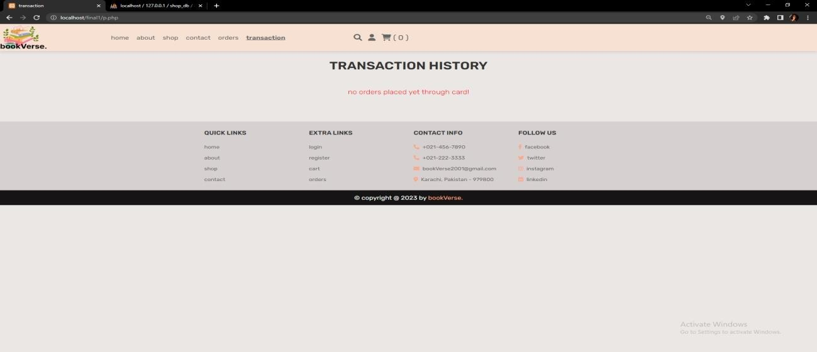

#### 1.3.7 Contact

* + - * + The Contact us page is like a help desk for user.
        + User can inquire anything about the website, order or product.
        + In order to contact, user have to be registered first.
        + User has to fill the form that consist of name, email, number and message box, where he can write any suggestion or query.

